

CS 319

Object-Oriented Software Engineering  
Fall 2014

**Conquerors**

User’s Guide

Group H  
Çağla Arıkan

Metin Enes Uçan

Can Akgün

İsmail Can Dereli

Table of Contents

1. Introduction 3

2. System Requirements and Installation 4

2.1. System Requirements 4

2.2. Installation 4

3. Playing the Game 4

3.1. Game Overview 4

3.2. Game Menus 4

3.2.1. Main Menu 5

3.2.2. Level Selection 5

3.2.3. View Help 6

3.2.4. Change Settings 7

3.2.5. High Scores 8

3.2.6. View Credits 9

3.2.7. Game Exit 9

3.3. Game Objects 10

3.3.1. The Hero 10

3.3.2. Castle 10

3.3.3. Soldiers 10

3.3.4. Cannonball 10

3.3.5. Walls 11

3.3.6. Mine 11

3.3.7. Treasure Chests 11

3.4. Bonuses 12

3.4.1. Power-ups 12

3.4.2. Bad surprises 12

3.5. Level System 12

3.6. Score System 13

3.7. Controllers 13

4. Game Screenshots 14

4.1. Level 1 14

4.2. Level 5 14

4.3. Game-Over Screen 15

5. Reviews and Comments 16

# Introduction

“*Conquerors*” is an arcade game which is inspired from the Atari game “*Volfied*”. The aim of this game is to conquer the castle by drawing lines before time runs out. However do not think it will be easy. During the game you will face with different enemies that will obstruct our hero to reach the goal. The game will have five different levels and as levels passed the game will be harder to master.

# System Requirements and Installation

## System Requirements

* JAVA SE8 is required.
* Windows 2000/XP/7/8
* Pentium2 233 MHz CPU or higher.
* Screen resolution must be at least 1920x1080 p.

## Installation

Conquerors.jar file should be executed to start the game. Moreover if you have the knowledge the game can be opened by opening the code file and running it.

# Playing the Game

## Game Overview

The game is played by moving the *hero* by using the arrows on the keyboard. If *hero* is able to move from one edge to another without colliding any other object on the game screen, it will conquer the land between the lines it drew. If that area has the castle in it then the level is passed. Fifth level is the last level of the game. Thus when the player conquers the castle on the fifth level then they will win the game. The *hero* starts with only one life. Lives can be earned if *life plus* bonus is earned. When the hero hit an object the hero will lose a life. When life is zero then the game is over.

## Game Menus

### Main Menu

The game starts by showing a main menu. The screenshot of main menu is shown below.

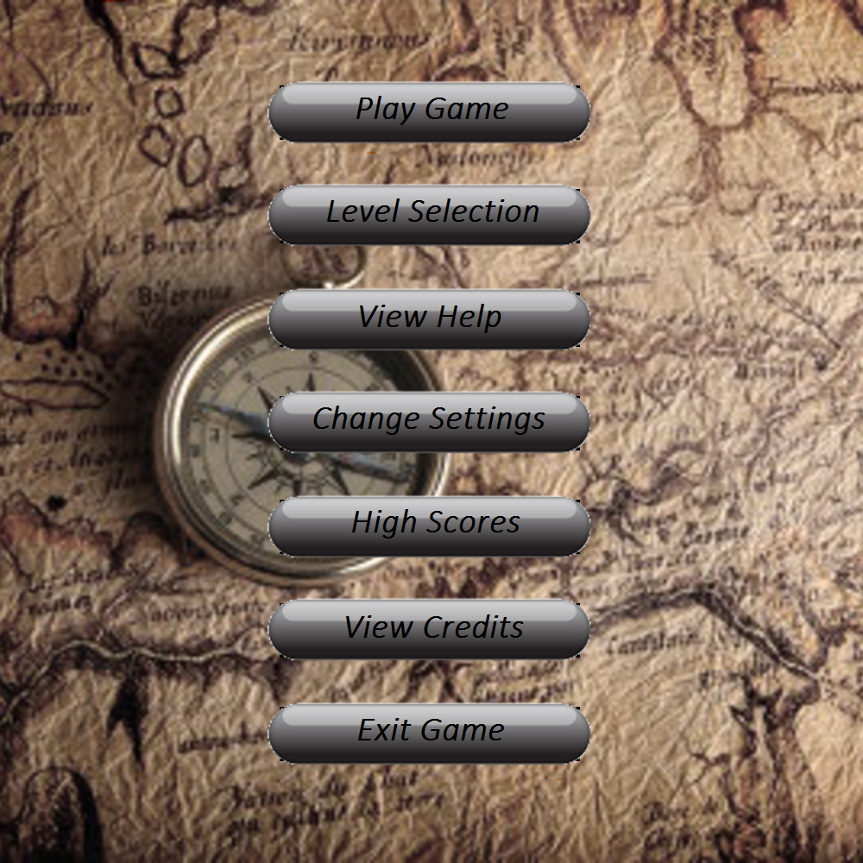

As seen above the user is able to choose options *play game, level selection, view help, change setting, high scores, view credits and exit game* from that menu.

### Level Selection

When the user clicks on the “Level Selection” button on the Main Menu, this section is opened. In that menu one can choose the level they desire the play by clicking buttons shown below.

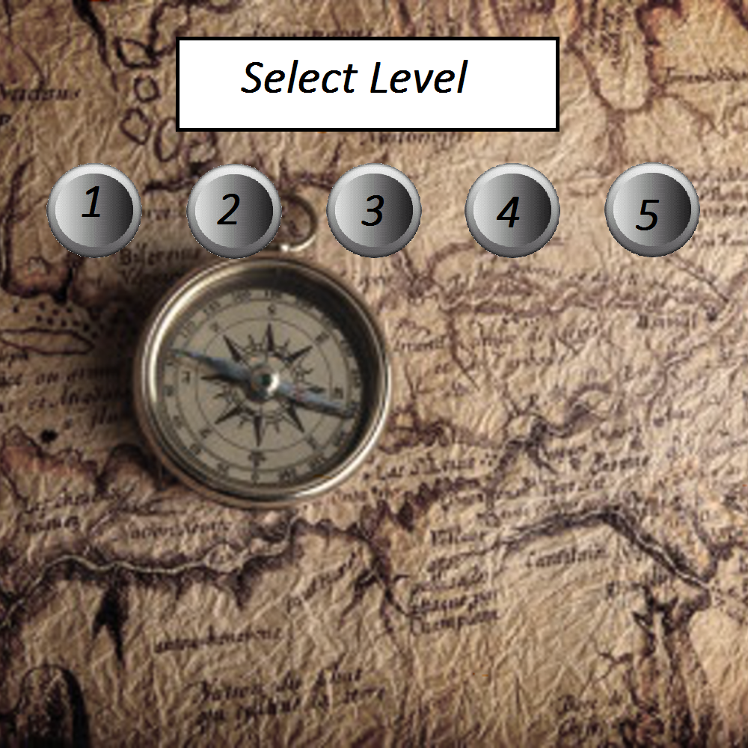

### View Help

When the user clicks on the “View Help” button on the Main Menu, this section is opened. In this section the player gets information about the objects in the game and how to play the game.

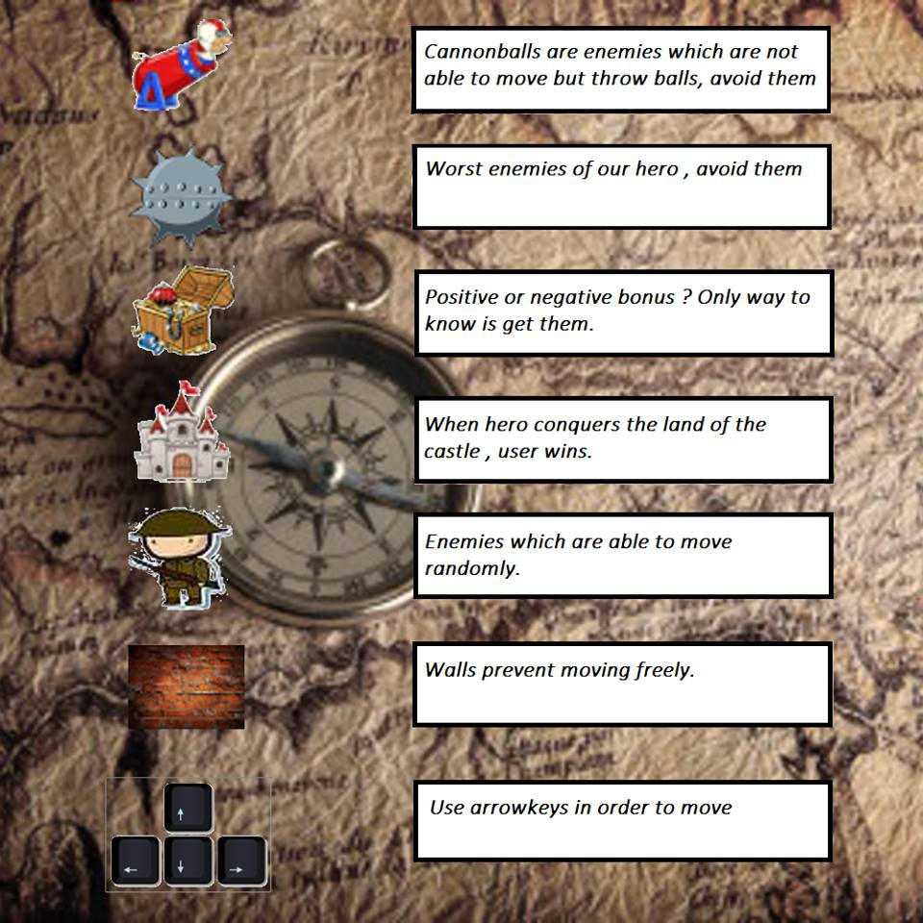

### Change Settings

When the user clicks on the “Change Settings” button on the Main Menu, this section is opened. In that menu one can choose the hero type that they desire the play with by clicking buttons shown below. However this feature does not work.

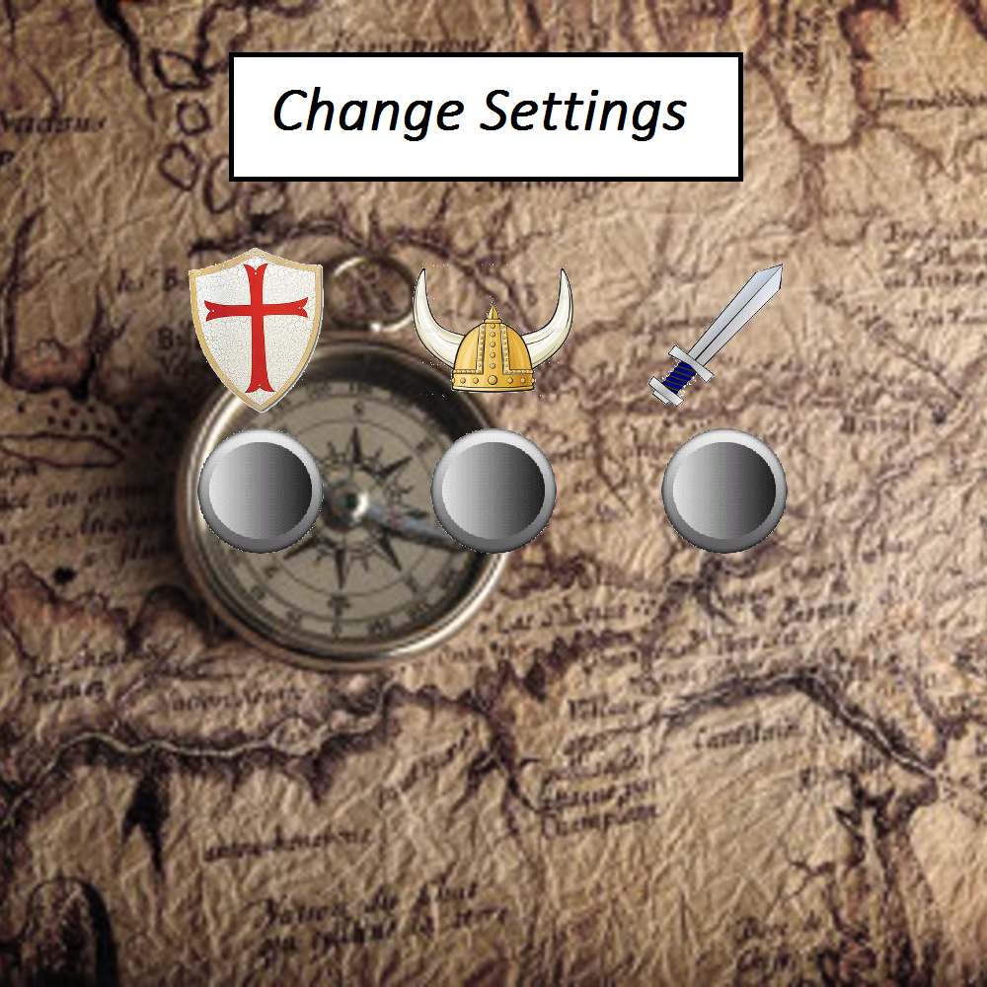

### High Scores

When the user clicks on the “High Scores” button on the Main Menu, this section is opened. In that section the user is able to see the top five high scores. If the user creates a new high score his/her score is added to the list and the lowest one is deleted.

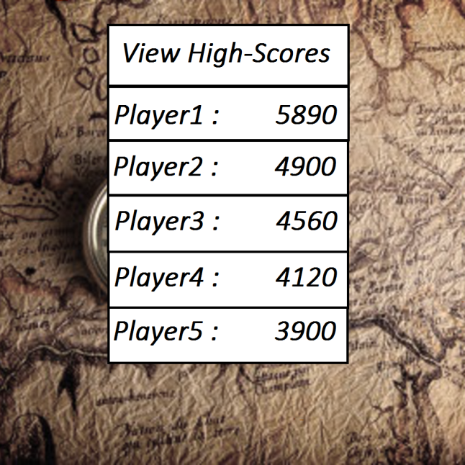

### View Credits

When the user clicks on the “View Credits” button on the Main Menu, this section is opened. In that section the user is able to see the information of the developers.

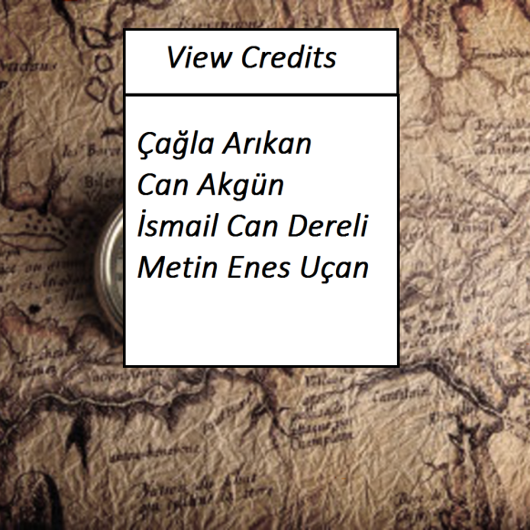

### Game Exit

In order to exit the game the “Exit” button on the Main Menu should be clicked.

## Game Objects

The game has several objects in it which have different properties.

### The Hero



Hero is represented by a shield. Hero is the main character of our game which is controlled by the user. It is the only character that user controls.

### Castle

C:\Users\cgl\AppData\Local\Temp\Rar$DIa0.016\castle.png

Castle object is a very important one in our game. Its position is fixed for each level. The area that the castle lays must be conquered to win the game.

### Soldiers

C:\Users\cgl\AppData\Local\Temp\Rar$DIa0.748\1.png

They are the enemies of our hero. They move randomly. If hero collides with them the hero loses its life. In order to kill them, the area that they stand must be conquered.

### Cannonball

https://fbcdn-sphotos-h-a.akamaihd.net/hphotos-ak-xpa1/v/t34.0-12/10841478_10153058685424560_232034745_n.jpg?oh=beb82d1b5f74f8a23f79a3981afe80cc&oe=549B64FB&__gda__=1419490026_87a2e65398c5d9dc03e08435aa511bf5https://fbcdn-sphotos-h-a.akamaihd.net/hphotos-ak-xpf1/v/t34.0-12/961477_10153058685499560_1390756599_n.jpg?oh=d4502b14b902d72bc69945d1e9ac8dce&oe=549BC22E&__gda__=1419508414_d5ffd420ad31040583eb0591ceb69940

They are not able to move but they will throw balls which will move in a horizontal line. Just like for soldiers, they will be killed by conquering the area that they stand and colliding with them will cause hero to lose a life.

### Walls

C:\Users\cgl\AppData\Local\Temp\Rar$DIa0.034\2.png

Walls will prevent our hero move freely. They will be the obstacles on its way. They will be placed in random places and they are not able to move. Touching them will make hero to lose its life. Getting rid of them is achieved by conquering the area that they are on.

### Mine

C:\Users\cgl\AppData\Local\Temp\Rar$DIa0.712\mine-----.png

Mine is another enemy of our hero. Its position will be fixed. Conquering the land, which mine stays, will destroy it.

### Treasure Chests

C:\Users\cgl\AppData\Local\Temp\Rar$DIa0.030\hazine2-------.png

Treasure chests represent bonus objects. They will come up at a random time of the game and will appear for limited time. Two or more bonuses can appear at the same time, there is no limitation for that. Their location will be random too. They can be either a positive or a negative, their looks are the same. If user wants to get them their location should be occupied.

## Bonuses

### Power-ups

* **Life Bonus:** As it can be understood from its name, it will add a life to our hero. If they hit an enemy they will not die instantly thanks to that bonus.
* **Time Plus:** It will increase the game time by 5 seconds.
* **Enemies Gone:** All enemies are destroyed when this bonus is taken.

### Bad surprises

* **Time Minus:** It will decrease the game time by 5 seconds.
* **More Walls:** After getting that bonus, suddenly walls will be built around the castle. When walls are built, the land which should be occupied to pass the level will be bigger. That will make hero’s work harder.

## Level System

The level system of the game will be explained at the table below.

|  |  |  |  |  |  |
| --- | --- | --- | --- | --- | --- |
|  | **LEVEL 1** | **LEVEL 2** | **LEVEL 3** | **LEVEL 4** | **LEVEL 5** |
| **GAME LENGTH** | 210 seconds | 180 seconds | 150 seconds | 120 seconds | 90 seconds |
| **AMOUNT OF SOLDIER** | 2 | 2 | 2 | 3 | 3 |
| **AMOUNT OF CANNON** | 0 | 0 | 1 | 1 | 2 |
| **AMOUNT OF WALLS** | 0 | 0 | 1 | 2 | 3 |
| **AMOUNT OF MINE** | 0 | 0 | 0 | 0 | 1 |
| **AMOUNT OF POWER-UP** | 8 | 7 | 6 | 5 | 4 |
| **AMOUNT OF BAD SURPRISES** | 2 | 3 | 4 | 5 | 6 |
| **COEFFICIENT FOR FINAL POINTS** | X1 | X2 | X3 | X4 | X5 |

**Table 1:** Table which shows the properties of all of the levels

## Score System

The score system is based on the time. At each level different time intervals are given. After one passes a level, time left is taken and multiplied by the coefficient which is different for each level (see 3.5. Level System). You earn points for each level and that point is added to the previous level(s) points. For example you pass level 2 and you had 15 points from level 1 and you got 10 seconds left. That 10 will be multiplied by 2 which is 20 and your final point will be 35.

## Controllers

The player is able to move the *hero* by using arrow key at the keyboard.

 This is used to make *hero* go up.

 This is used to make *hero* go down.

 This is used to make *hero* go right.

 This is used to make *hero* go left.

# Game Screenshots

## Level 1

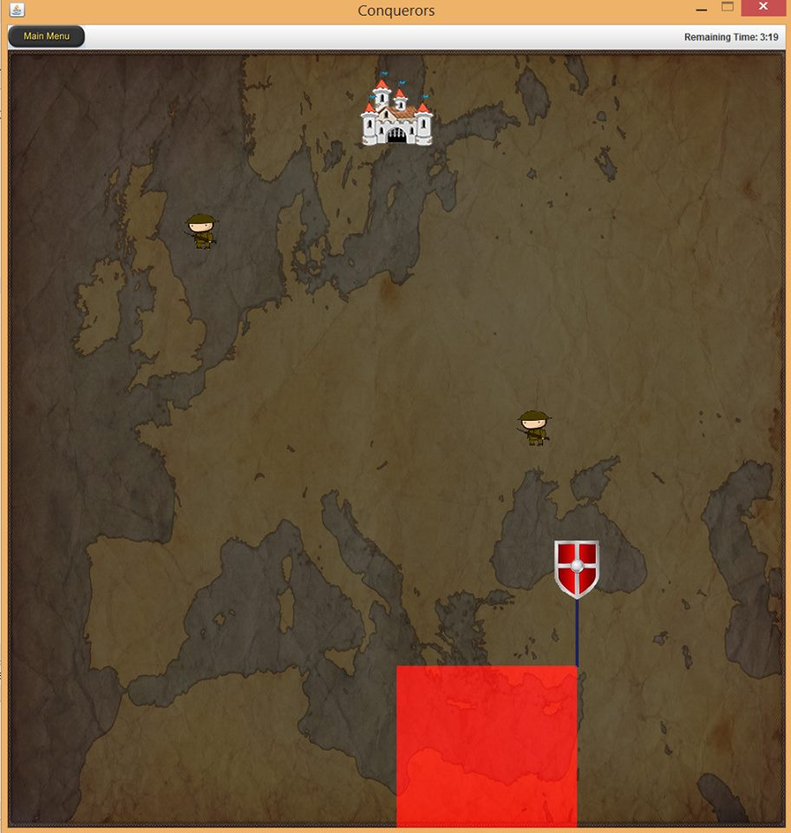

This screenshot is taken while playing level 1.

## Level 5

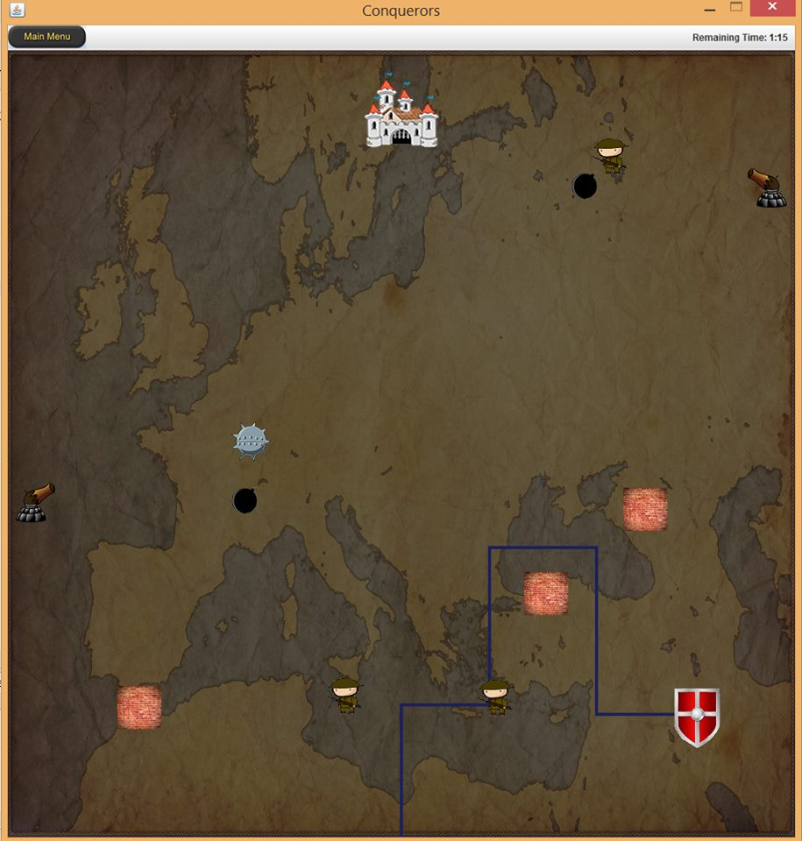

This screenshot is taken while playing level 5.

## Game-Over Screen

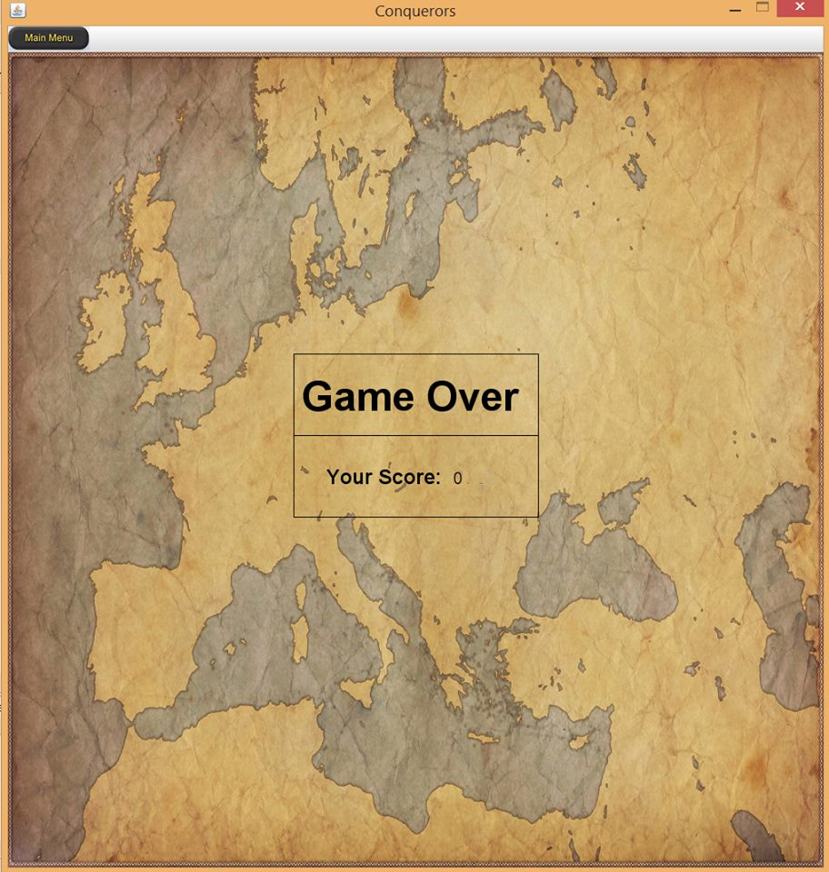

# Reviews and Comments

We want to make our game as good as possible. Thus we are open to any reviews and comments. To reach us one can use the e-mail addresses given above.

cagla.arikan@ug.bikent.edu.tr

can.akgun@ug.bikent.edu.tr

dereli@ug.bilkent.edu.tr

metin.ucan@ug.bikent.edu.tr